**SPH3U: 3.2 Newton’s First Law of Motion**

1. **Inertia**

|  |  |
| --- | --- |
| Inertia: |  |
| Newton’s first law of motion |  |
| Isaac Newton |  |
| Galileo Galilei’s thought experiment |  |

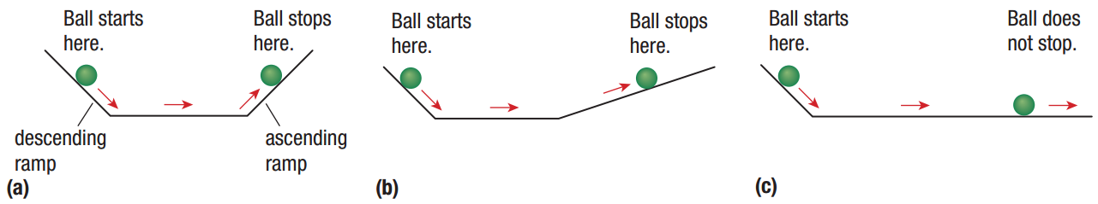

Use Newton’s first law to explain each situation below:

1. Why does a computer sitting on a desk remain at rest?
2. Why does a hockey puck moving across smooth ice move at a constant velocity?
3. Why does a wagon pulled across a rough surface by a child move at a constant velocity?

Older cars did not have headrests, but all new cars do. How do headrests help prevent injuries during a rear-end collision? Use Newton’s first law to explain your answer.

What is the missing force on each FBD shown below? Figure a) is an object at rest and Figure b) is an object moving left at a constant velocity.

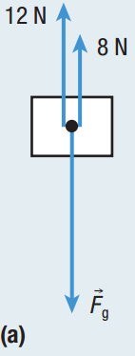 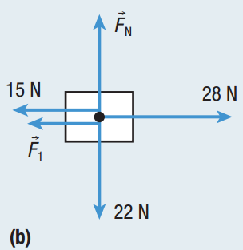

1. **Applications of Newton’s first law**

|  |  |
| --- | --- |
| Seat belt: |  |

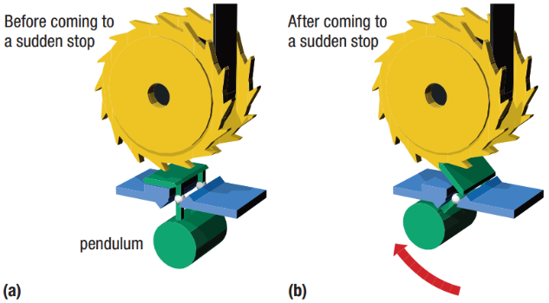

**Homework:** page 129: #2-4, 7, 10, 13